BPM ( Business process management)
Bpm provides the platform on which all the processes can be implemented, modeled, designed executed and monitored.
People uses different methods to implement, model, monitor and execute the business processes
I0

1) Difference between epv and env

Epv —we can change epv’s at runtime and epv’s are any type

Env —we can change env’s explicitely and env’s are always string type

Scenario:
Imagine you have a process for Order Approval.
- You want to configure the max approval days (business logic → EPV).
- You also need the external system API endpoint (environment-specific → ENV)
EPV: In Process Designer → go to your Process App → Variables → Exposed Process Variables (EPV).
Create EPV:
  - Name: MaxApprovalDays
  - Type: Integer
  - Value: 7
This means: default approval deadline = 7 days. At runtime, admin can update to 10 without redeployment in process admin console
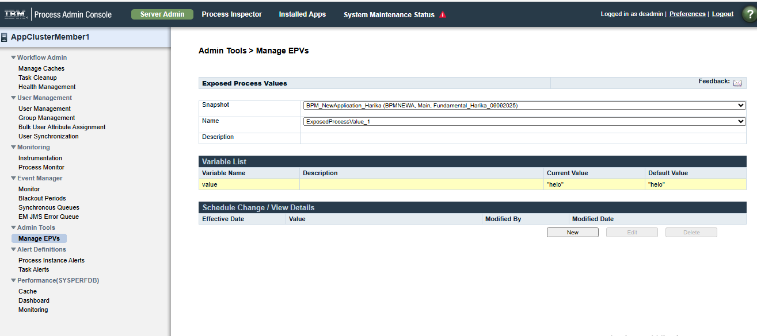
ENV:
- In Process Admin Console → Environment Settings → Environment Variables.
- Create ENV:
  - Name: API_ENDPOINT
  - Type: (always string)
  - Value: https://test-api.company.com/approval
✅ This means: in Test environment, API is test URL.
✅ In Prod, you can set another value like https://prod-api.company.com/approval.

Example for ENV variable
In process app, process app settings, environmental variable are there, so create one env and values as shown below
Key—envVariable(name)
Default- jdbc/ccms(data source name it will used in services)
So in services, for data source name ,we will use “envVariable” instead of using “jdbc/ccms”
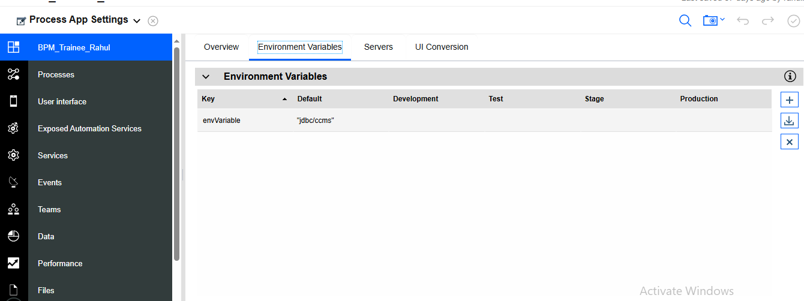

In future if we want to change the data source name ,we can direct change the value in environmental variables, no need to change in all the service, so that we have use ENV variables
Example for EPV variable
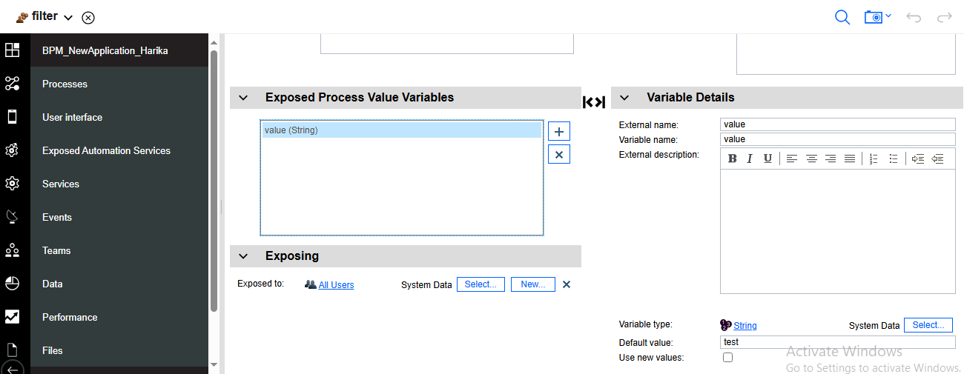
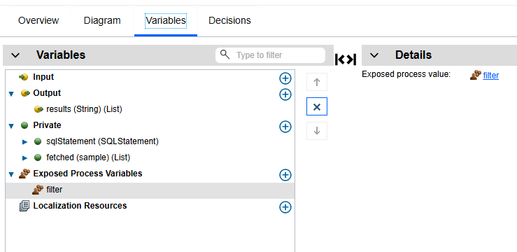
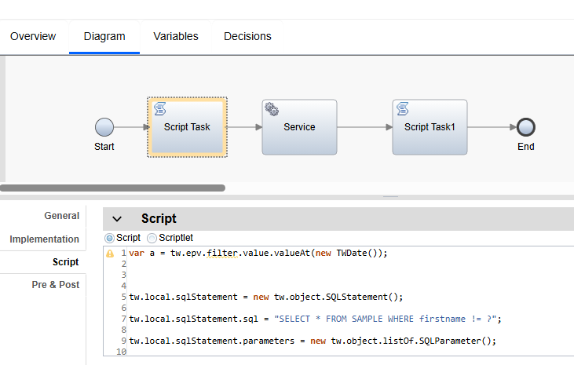
Script:
var a = tw.epv.filter.value.valueAt(new TWDate());

tw.local.sqlStatement = new tw.object.SQLStatement();

tw.local.sqlStatement.sql = "SELECT * FROM SAMPLE WHERE firstname != ?";

tw.local.sqlStatement.parameters = new tw.object.listOf.SQLParameter();

tw.local.sqlStatement.parameters[0] = new tw.object.SQLParameter(); // First Name
tw.local.sqlStatement.parameters[0].value = a; // First Name
tw.local.sqlStatement.parameters[0].type = "VARCHAR"; // Type for First Name
tw.local.sqlStatement.parameters[0].mode = "IN";

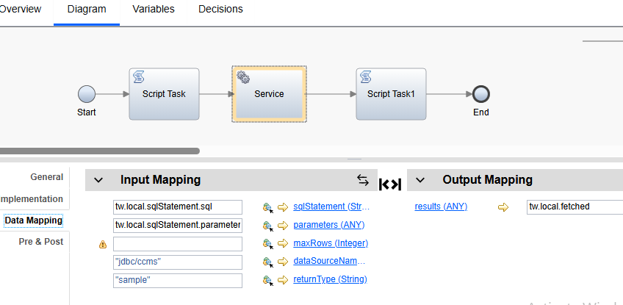
Script1:
tw.local.results =[];
for (var i = 0; i < tw.local.fetched.length; i++) {

tw.local.results[i] = tw.local.fetched[i].firstName;
}

2) Linked process and Sub process
Linked process is reusable
This process reduces number of activities in main process
This is dark in colour
We can use this process in multiple processes
Calls another process, after linked process completes, parent class resumes execution

Sub process is child process of parent process
We can use this process in only one process that is parent process
This is light in colour
Encapsulates a collection of logically related steps contained within the parent process

3) How many ways to start BPD
We can use 4 ways to start bpd

1) by using service:- to start bpd by service, we use method “startprocessbyname” with arguments process name and map
startprocessbyname(“process name”, map)

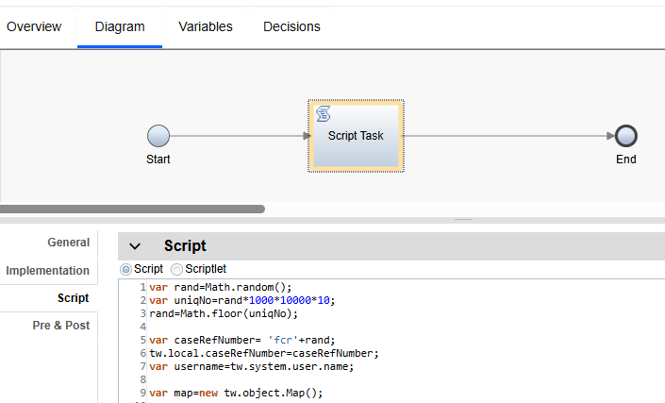

var rand=Math.random();
var uniqNo=rand*1000*10000*10;
rand=Math.floor(uniqNo);

var caseRefNumber= 'fcr'+rand;
tw.local.caseRefNumber=caseRefNumber;
var username=tw.system.user.name;

var map=new tw.object.Map();

map.put("caseRefNumber",caseRefNumber);
tw.system.startProcessByName("Fundamental Credit Reviewer Process",map);
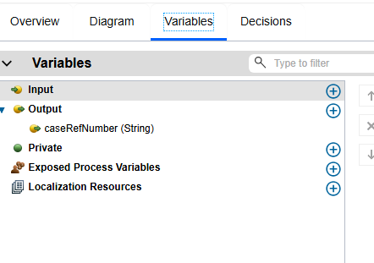

2) by using uca

We have to create service to start bpm and attach that service to UCA and run uca, then process will be started

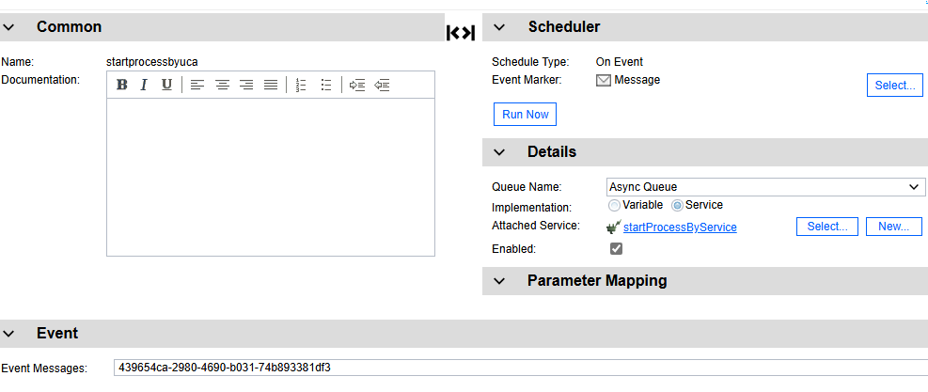

3)by using rest api tester

We have to open rest api tester
REST API Tester

Click on IBM Business automation workflow rest api, in that click on process api and then click on exposed process and execute then all exposed process will be appeared here, then click on start process ,give itemid, process app id and snapshot id of process which we want to start, then the process will be started

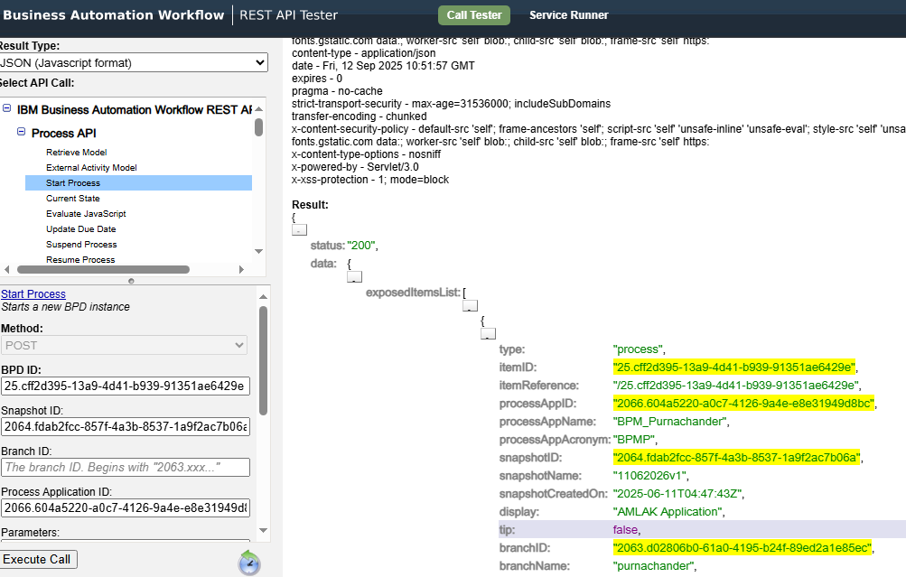

4) In process app, in process , we have one option “expose to start “ ,there we have to add exposed to all users, then this process will be seen in process portal and from that we can claim the process and start, we can also start the process by this way
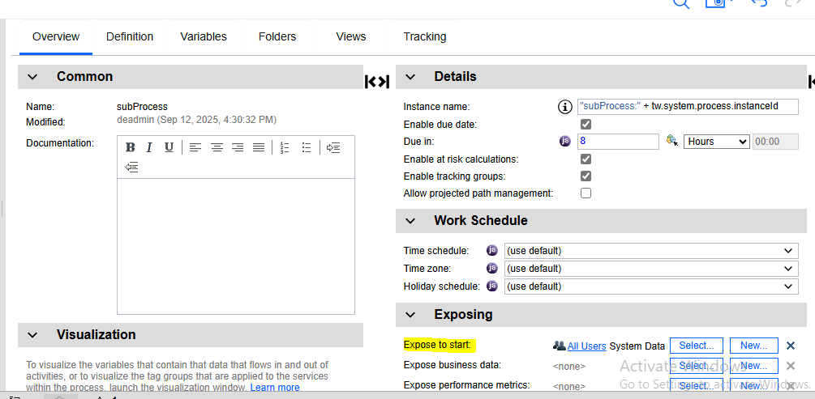

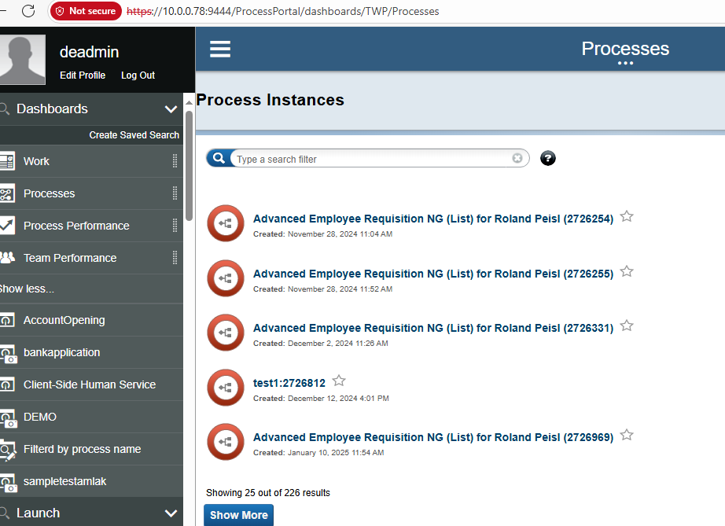

5) through jms
6) through java api

4) How to expose BAW Services

We can expose bpm services in two ways they are rest service and web service
Exposed automation services—rest service and web service

Rest service: create rest service, add operation, in that we have to select our service which we want to expose and give the name then open api definition url will be generated, we have to give that url and expose our service

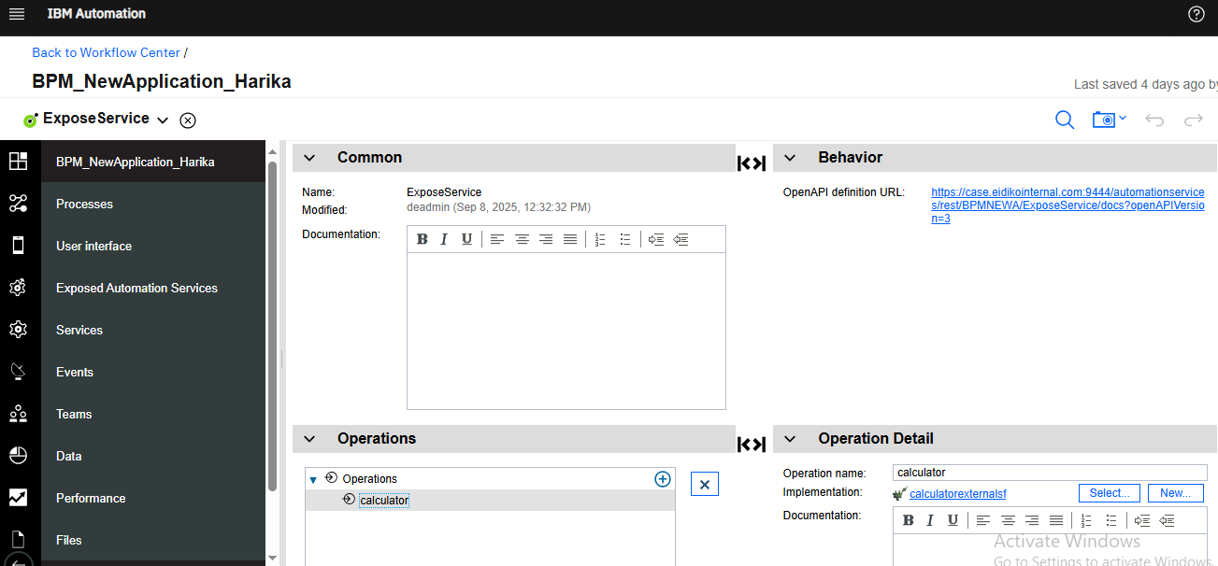

Web service: create web service, add operation, in that we have to select our service which we want to expose and give the name then wsdl url will be generated, we have to give that url and expose our service
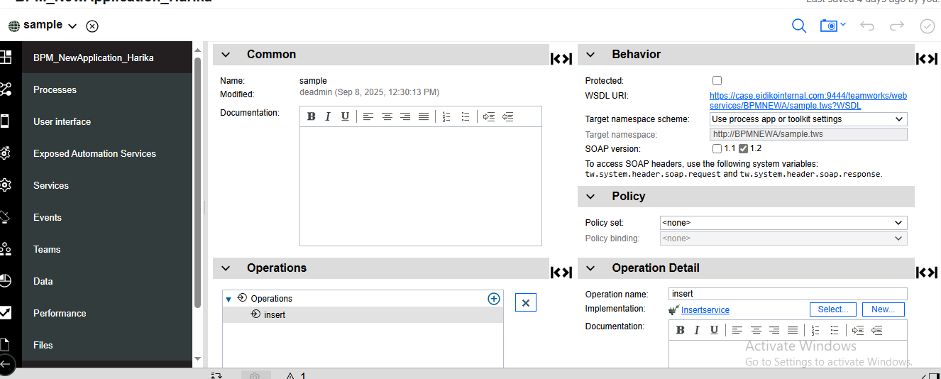

5) What is process and BPD
Process
Set of activities involved in business process is called process
We use different components and design the process
Task: - task is activities that present inside the process; they are user task, inline user task and system task
User task: - user task performed by the person and implemented by client side human service
Inline user task: - it is performed by the person and it does not require any implementation
System task: - system task is performed by system and it is implemented by heritage human service, service flow and external service

Process application
We can create applications through process centre console, we should give name and acronym, acronym should be unique and it must contain only up to seven characters

Instance
Instance is created by the process for each run, it is unique number

Process Instance
When process starts, new instance will be created, it is unique id value

Bpd (Business process definition)
Bpd represents overall view and flow of the process, it represents model of the process
Bpd is divided into lanes and milestones, horizontal lines are called lanes and vertical lines are called milestones, lane is the container for all the activities to be carried out by specific team or system, we place all the activities in lane

6) Ajax call
The main purpose of ajax call is without populating the data , the view should be load, it reduces the screen time
it prevents the execution of services on server side, so the bit of execution time is saved

Structure of ajax call

params: -it represents input to the service
load: -it is call back function, when service call returns successfully, it contains only one parameter, that is output of service call
error: -it is call back function, when service call returns error, it contains error information

Life cycle of ajax call

header html
inline css
inline javascript
load
view
change
unload

bind this
We use this, when we want to pass current value to the function

Bind method
This method is used to bind object to the function, so that the function gives different result when its needed otherwise it gives same result or error which executing code

Bind all
This method binds number of methods on object

Json.stringify
When object is provided ,it is serialized into json format by using json.stringify

we can initialize bo in ajax call by using {}
we can initialize list bo in ajax call by using []

7) Offline deployment and Online deployment

Offline deployment: it is done by admin through WAS(web sphere application server) console

Online deployment: In process center , we have select application which we want to deploy, snapshots will be available there, beside snapshot, there will be three options like export ,install and open in designer, we have to click on install and select the server like dev, test, production to which we want to deploy the application and click on install, then process will be deployed to other server
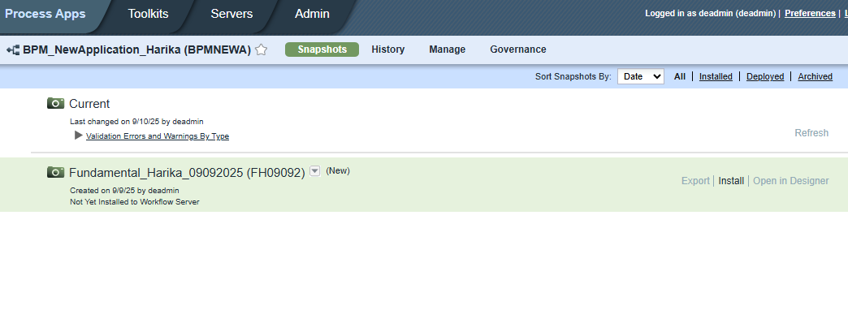

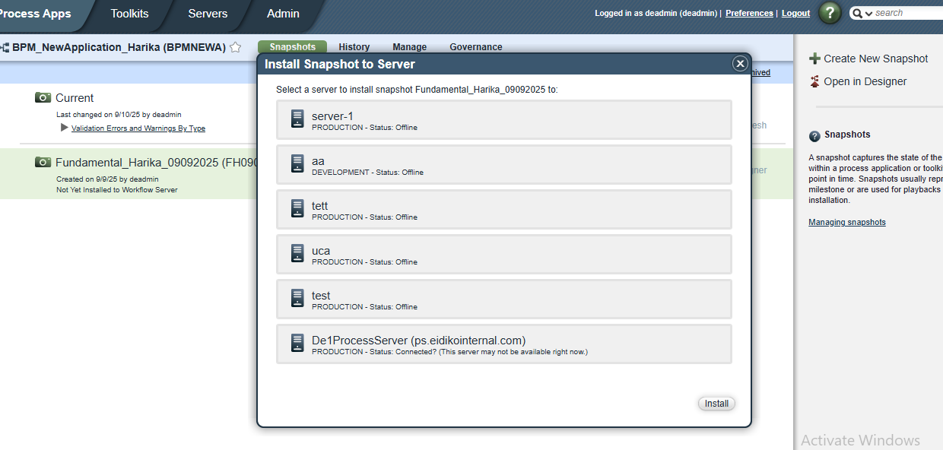

8) Types of consoles and uses

Process Portal
Process Center
Process Admin
Process Inspector

Process Center: in process center, we can create applications and deploy the applications
It includes repository for all the processes ,services and other assets in ibm bpm that autorizing environments process designer and integration designer
it has two servers process center server and performance data warehouse server

process center server:-in this, we can design the applications and run in process center server and store the data
performance data warehouse server:-it is used to retrieve the data from process center server

Process Admin : It manages users, groups and epv’s and applications
To identify the performance issues with your process application, view the performance data available in process monitor page of process admin console

Process Inspector:
In process inspector, we have types active, completed, terminated, suspended and failed, when we click on active, it will show all the processes which are in active state ,it will give process information like instance id, created date.....
it will give the information of all the processes which are in which state

Process Portal: we can expose process, coach to process portal, we can claim that and work on that processes
Process portal enables process participants to perform assigned task, view the history of task, launch any processes or services that are attached to task and view the performance of their processes and teams

9) Snapshot
It records the current state of items at specific point of time
Snapshot limit—128
Named snapshot—we will create new snapshots as name-date-time (ccms-20052021-1508)
Unnamed snapshot—created automatically when you save your Process App in Process Designer. When we run process or service, unnamed snapshots will be created

10) Differnce between bpm and baw

To work with bpm, we have to install the server and work on that server only
To work with baw, we no need to install the server, by using ip address, we can access from anywhere

IBM BPM (older platform)
- Traditionally installed on-premises (in your data center or on your local machine for dev).
- You had to:
  - Install the BPM server software,
  - Configure databases,
  - Start the server,
  - Then connect to it via browser (usually http://localhost:9080/...).
- That means: you only work on the server where BPM is installed (unless the server is exposed on a network).
👉 Example:
If BPM is installed only on your laptop, only you can access it.
If it’s installed in your company data center, only people in that network can access it.

IBM BAW (Business Automation Workflow)
- Newer platform, more cloud-friendly.
- It can run:
  - On-premises (like BPM, if your company chooses), or
  - On Cloud / Containers (Kubernetes, OpenShift, IBM Cloud Pak).
- When deployed centrally, it’s accessed through a web browser using an IP or hostname (like http://baw.company.com).
- So, from anywhere (with network/VPN access), you just log in with the URL → no need to install the whole server locally.
👉 Example:
You sit at home, open your browser, enter http://baw.company.com, and start designing processes (because the BAW server is running in your company’s cloud or data center).
BPM: “We must install and work only on that machine/server.”
BAW: “No local installation needed. Access it via IP/URL from anywhere (if you have permissions).”

11) Variables

Input Variable
If service wants to run itself, it requires some input data from other service, so it uses input variables to get the data from other service

Output Variable
This variable is used to pass value to other service

Private Variable
This is independent variable, it does not depend on other service, it does not require data from other service and it perform the operation

12) Themes
A Theme is basically a style package (CSS, fonts, colors, sizes, layouts) applied to your BPM/BAW user interfaces (Coaches).
Instead of manually styling each button, label, or table, you define the look once in the theme.
The theme then applies automatically to all UI components.

Themes are used for changing the colours, sizes...
By using themes, we can save the time, it improves the performance

13) UCA
- UCA (Under Cover Agent) is an asynchronous event handler in IBM BPM.
- It is mainly used for event-driven behavior, meaning it listens for a trigger (like a message, timer, or system event) and then wakes up a process to act on it.
- Think of it as a background agent that waits for an external/internal event.

🔹 Types of UCAs
- Message-based UCA
  - Triggered when a message event is received (for example, another process sends a message).
  - Used for inter-process communication.
- Timer-based UCA
  - Triggered at specific time intervals or schedules.
  - Used for reminders, escalations, or batch-like processing.

🔹 Where is UCA used?
- Intermediate Events
In a process diagram, if you place an intermediate message or timer event, it is implemented under the hood using a UCA.
- Start Events
A process can also be started by a message event (again, through a UCA).

🔹 Key Points
- UCAs decouple process execution from the event trigger.
- They are asynchronous (non-blocking).
- They allow processes to be started, resumed, or interrupted based on external signals.
- They are configured in the Process Designer, but managed at runtime by the Process Server Event Manager.

✅ Example use case:
- You have a loan approval process.
- If no action is taken within 48 hours, a timer-based UCA triggers an escalation sub-process to notify the manager.
- If an external system sends an update message, a message-based UCA can resume the waiting process instance.

14) Tracks

Track is an optional sub division in a process application based on team tasks or process application versions,if additional tracks are necessary for process application,we can enable them at any time

Creating new tracks in process center console
-->select process apps or toolkits tab
-->select process application or toolkit for which you want to create new track
-->if snapshot does not exist,create one by clicking on create new snapshot
-->click new track option for snapshot
-->enter name and optionally a description & click save
-->to access new track,click tracks dropdown menu & select track that you want
-->to open new track in designer,click on <name of the track> in designer

In IBM BPM / BAW, tracks are used for parallel development inside a process application or toolkit.
Here’s why we use tracks:
- Parallel development without conflict
  - Suppose multiple developers are working on the same process app.
  - One team is building a new feature, and another is working on a production bug fix.
  - Instead of overwriting each other’s changes, you create a track → each team works in isolation.
- Experimentation / prototyping
  - You might want to try out a new design or workflow improvement without disturbing the mainline (tip).
  - A track lets you do that safely.
- Version management
  - A track acts like a branch in version control systems (Git/SVN).
  - You can keep stable code in the mainline (tip) while working on changes in the track.
- Merge later
  - After the feature or fix is tested and approved, you can merge the track back into the tip.
  - This ensures controlled integration.
📌 In short:
We use tracks in BPM for isolation of changes, safe parallel development, and controlled merging — very similar to branches in Git.

Open snapshot for which you want to create track, click on manage, and click on check box “allow users to create tracks in this process app”.
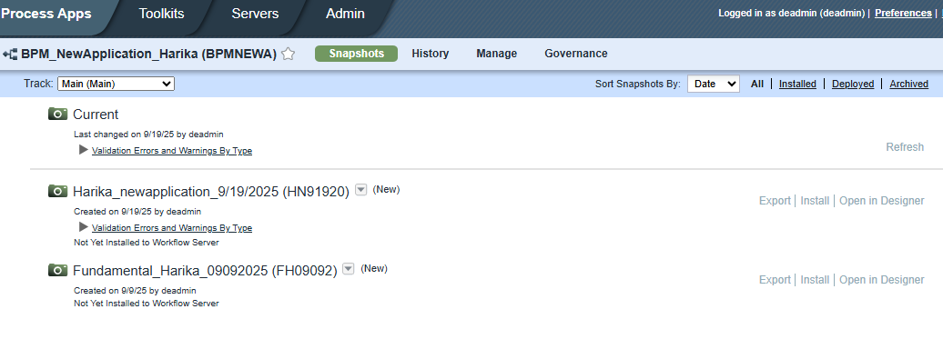

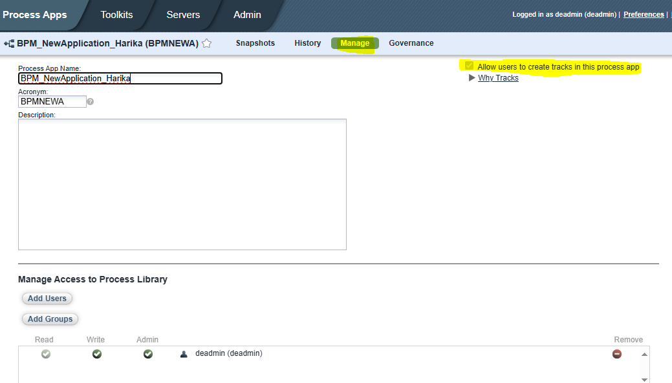

Below, we can see new track for snapshot, click on that, give the name and create new track for that snapshot
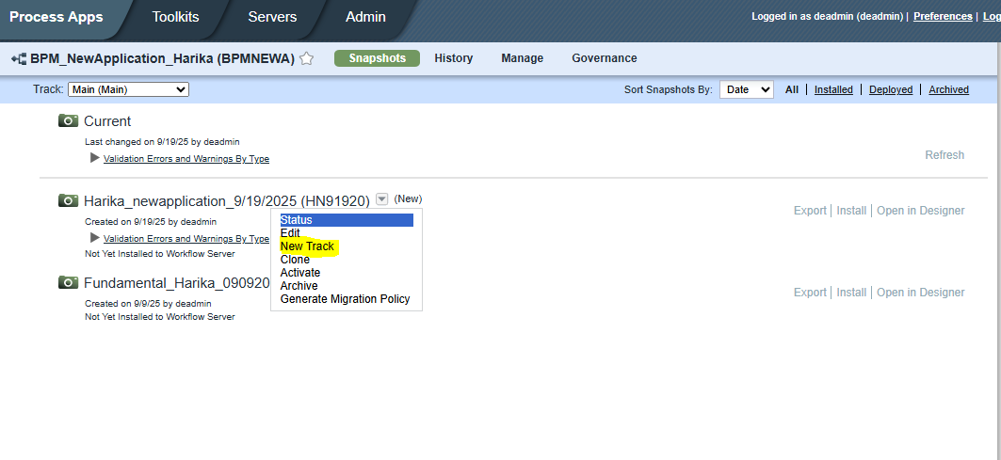

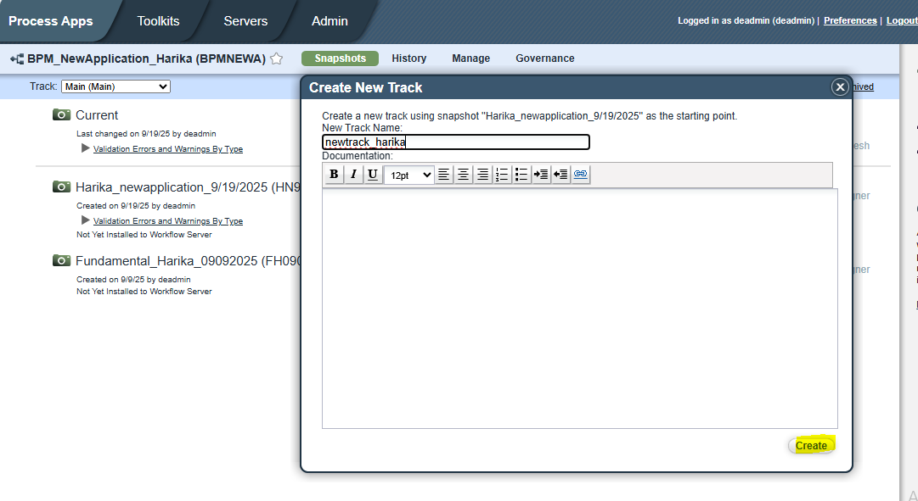

Scenario: if we want to valid any text field, we can directly give regular expression as shown below

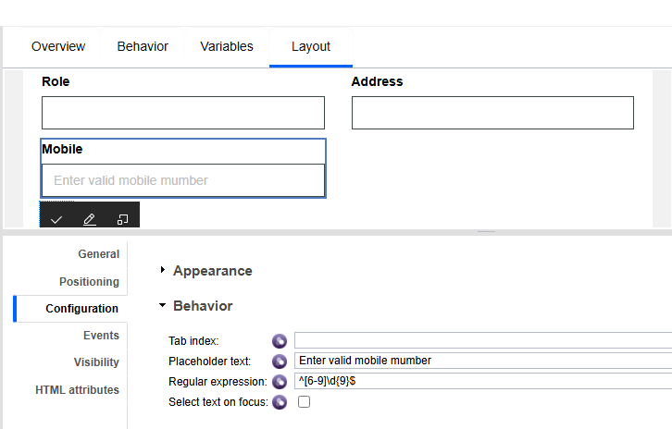

Scenario1:
.

